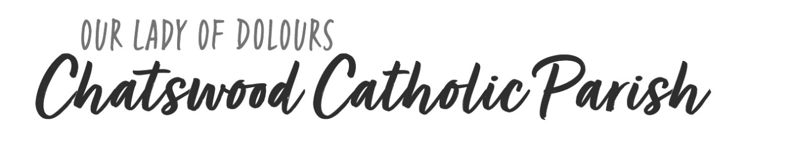
We invite you to book into a “Parents’ Connect Gathering” online at bbcatholic.org.au/Chatswood or by contacting Bernadette.ho@bbcatholic.org.au. Please complete this form and bring it along with you.
CHILD’S FIRST NAME |  | SURNAME
Address
Child’s religion |  | If Baptised, date and place
DETAILS OF PARENTS
Mother’s Name |  | Religion
Father’s name |  | Religion
Email |  | Phone
Do you have a church community to which you presently belong? If so, which?
Describe your involvement in this or any church in the last ten years
How do you live out your faith and spirituality?
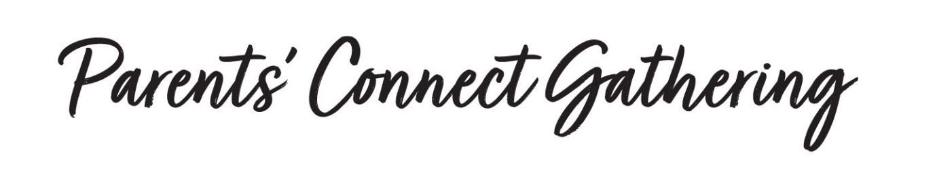
Relaxed, fun and informal, our gatherings offer a wonderful opportunity to:
- Connect with members of our parish team and meet other parents in our parish community.
- Reflect on the supportive faith partnership created between home, school and Parish.
- Discover pathways to belonging in our Parish family. You belong and we look forward to getting to know you and hearing about your family.
- Explore where you are on your faith journey and discover how our Parish seeks to support you to nurture your spiritual growth. Wherever you are on your faith journey, we welcome you and we’re glad you’re here with us.

WHERE DO WE MEET?
Designed for parents, the gatherings are held in the parish meeting rooms (Magnificat Room) located on the corner of Kirk and Archer Streets opposite the church. Either or both parents are welcome to attend.
BOOK ONLINE
Go to bbcatholic.org.au/Chatswood under the “schools” tab or contact Bernadette Ho Bernadette.ho@bbcatholic.org.au Ph: 9410 9031
We look forward to spending time with you!
Parents’ Connect Gathering dates for 2020
Saturday 7 March 2020 | 10- 11am
Saturday 4 April 2020 | 10 -11am
Saturday 16 May 2020 | 10 -11am
Saturday 13 June 2020 | 10 -11am
Saturday 8 August 2020 | 10 -11am
Saturday 12 September 2020 | 10 -11am

